Mr Bensley

Pupil Premium 2020-21
SWRA

Introduction
Rationale and Key Questions
What is the Pupil Premium?
The Pupil Premium is additional funding paid to schools in respect of their disadvantaged pupils (pupils who have been registered for free schools meals (FSM) at any point in the last six years or have been looked after by the local authority for at least one day. Schools receive this funding to support their eligible pupils and narrow the attainment gap between them and their peers. A premium has also been introduced for children whose parents are currently serving in the armed forces. This service premium is designed to address the emotional and social well-being of these pupils.
What is level of the Pupil Premium per pupil?
2020-2021 funding is allocated at £955 for any child in Year 7 to 11 recorded as Ever 6 FSM and £310 for Service Children. Pupils in care (Looked After Children) receive £2345 as do children who have ceased to be looked after by a local authority in England and Wales because of adoption, a special guardianship order, or child arrangements order (previously known as a residence order)
How much has the overall Pupil Premium funding increased since it was introduced?
Total funding through the Pupil Premium has been fixed for the last 5 years with no inflation adjustments made until this year. In essence this represents a decline in funding due to rising costs and funding this year is expected to be around £2.41 billion.
What is the aim or purpose of the Premium for service children? Is it to improve their progress and attainment?
In the main, service children achieve very well at school. However, schools have reported that there are additional needs relating to service children’s emotional and social well-being. In the past, extra support often had to be accommodated from within their existing budgets. Schools will be able to use the Service Premium to fund this additional pastoral care, if they feel that is appropriate

How are schools accountable for how they use the Pupil Premium?
Head teachers are free to decide how best to use the Premium to support their Ever6 FSM and Looked After pupils and close the attainment gap between them and their peers. The Department does not want to micro-manage schools, but it does expect them to use the Pupil Premium appropriately and to be accountable for the decisions they make.
The Government believes that head teachers and school leaders should decide how to use the Pupil Premium. They are held accountable for the decisions they make through:
- the performance tables which show the performance of disadvantaged pupils compared with their peers
- the new Ofsted inspection framework, under which inspectors focus on the attainment of pupil groups, in particular those who attract the Pupil Premium
- the new reports for parents that schools now have to publish online
What is the current state of play in regards to FSM nationally?

The percentage of pupils known to be eligible for free school meals has increased across all schools from 15.4% in 2019 to 17.3% in 2020. This follows a similar increase from 2018 (13.6%) to 2019.
Since 1 April 2018, transitional protections have been in place which will continue to be in place during the roll out of Universal Credit. This has meant that pupils eligible for free school meals on or after 1 April 2018 retain their free school meals eligibility even if their circumstances change. This has been the main driver in the increase in the proportion of pupils eligible for free school meals as pupils continue to become eligible but fewer pupils stop being eligible.

Entitlement has increased across most school types
- The percentage of pupils in state-funded primary schools known to be eligible for free school meals has increased from 15.8% to 17.7% in 2020.
- The percentage of pupils in state-funded secondary schools has also increased from 14.1% to 15.9% in 2020
- The percentage of pupils in state-funded special schools has increased from 38.3 to 40.1% in 2020

How should schools encourage parents to register their child’s eligibility for free school meals (FSM)?
There are a number of practices schools can adopt to encourage parents to register their children. In particular, schools should consider letting parents know:
• that registering their child as eligible for FSM will bring more money to the school to help their child achieve;
• what the school will spend the Pupil Premium on, so they are encouraged to apply;
• what, if any, other benefits may be available for children registered as eligible for FSM, i.e. help with the cost of music lessons or school trips;
• that registering for FSM is confidential and their peers, and their child’s peers, need not know they have applied; and
• what registering for FSM involves and what it means for their child, including the fact that taking up the meal is recommended but optional.
Options for communicating these messages to parents include:
• sending letters to parents explaining FSM, its link to the Pupil Premium and how to apply – sending more than once to ensure all parents see it;
• adding reminders to register for FSM in any regular newsletters or e-bulletins to parents;
• texting all parents asking them to contact the school office if they receive benefits, as they may be able to help secure extra funding for the school;
• ensuring reception teachers or parent liaison staff are talking to new parents about signing up for FSM when they carry out home visits;
• encouraging teaching assistants / parent liaison staff / learning mentors to have confidential conversations with parents about registering their children as eligible for FSM, particularly if they have English as an additional language, or lower levels of literacy;
• placing information about FSM and the Pupil Premium on your website;
• holding discreet and informative school assemblies on FSM and the Pupil Premium, giving pupil’s confidence that, if they register as eligible, it will be kept confidential.
Schools should let parents know that in simply registering their child as eligible for FSM the school receives additional funding that will be used to help their child achieve to the best of their ability. They should also remind parents of the nutritional and financial benefits of their children eating the free meals.
Further information on improving the dining room environment to encourage children to eat their free meals can be found on the Children’s Food Trust website.
SWRA - Pupil Premium Policy
At Sir William Robertson Academy all members of staff and governors accept responsibility for those pupils recognised as ‘disadvantaged’ and are committed to meeting their pastoral, social and academic needs. Every child who is considered to be ‘disadvantaged’ is valued, respected and entitled to develop to his/her full potential irrespective of disadvantage. This is enshrined in the schools aim to encourage all pupils regardless of background to ASPIRE:
Achieve their full potential as individuals
Support each other as members of a caring community
Pursue knowledge and understanding
Involve themselves in the wide range of activities we offer
Respect other people’s values, beliefs and customs
Extend their horizons, striving to achieve their best
Underpinning these aims, and to ensure that pupils are enabled to achieve their full potential we will strive to ensure
- The very best possible delivery of learning experiences in the classroom.
- A range of group and individual interventions designed to support those with identified needs.
- A rich and varied menu of activities designed to engage and motivate pupils, raising their aspirations and creating a positive view of learning
Principles
- We ensure that teaching and learning opportunities meet the needs of all of the pupils.
- We ensure that appropriate provision is made for pupils who belong to vulnerable groups, this includes ensuring the needs of socially disadvantaged pupils are adequately assessed and addressed.
- Pupil premium funding will be allocated following a needs analysis which will identify priority, classes, groups or individuals. Limited funding and resources means that not all children receiving free school meals will be in receipt of pupil premium interventions at any one time.
- In making provision for socially disadvantaged pupils, we recognise that not all pupils who receive free school meals will be socially disadvantaged or underachieving. We also recognise that not all pupils who are socially disadvantaged are registered or qualify for free school meals. We therefore reserve the right to allocate Pupil Premium funding to support any groups of pupils the school has legitimately identified as being socially disadvantaged. This view is supported by historical research undertaken by LCC that suggests that under registration within the county is approximately 27%* and towards the higher end of the spectrum when compared to the national picture of variation between 0 and 33%* and it is suggested that this up to 4000* pupils eligible for FSM are currently not accessing this entitlement within the county. (*Taken from LCC report January 2013 produced by Head of Finance (Children’s and Specialist Services))

Provision
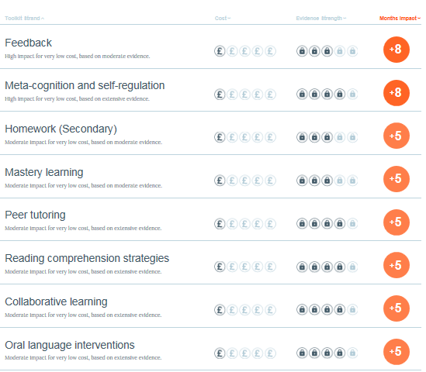
We will regularly seek to further develop strategies and interventions which can improve the progress and attainment of these pupils. Examples of the range of provision we may put in place have been derived through the use of the Sutton Trust Toolkit which outlines the likely Cost to Impact ratio of a range of possible interventions:

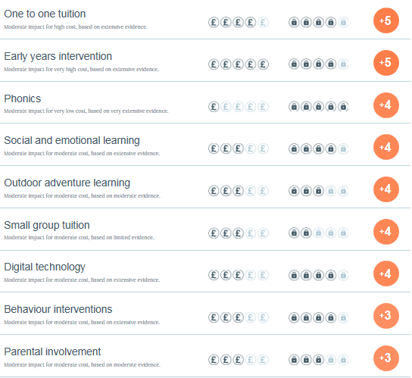

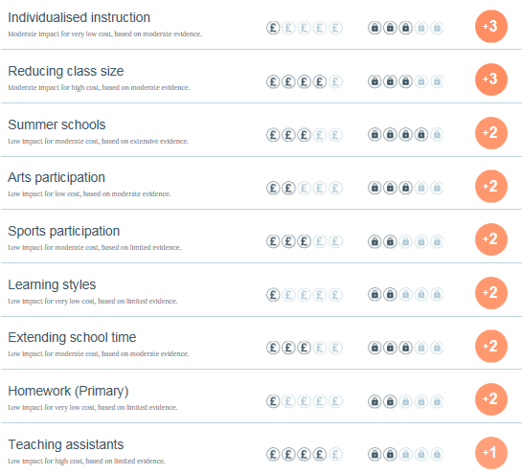

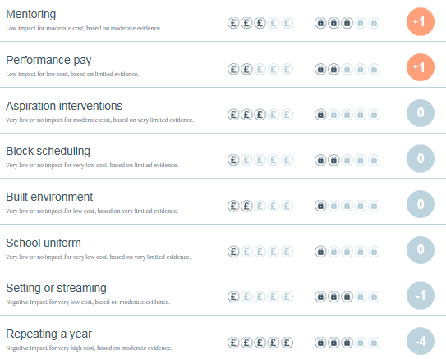

Reporting outcomes
- It will be the responsibility of the Headteacher to produce regular reports for the Governing Body that will include:
- The progress made towards narrowing the gap for socially disadvantaged pupils.
- An outline of the provision in place at the school
- An evaluation of the cost effectiveness, in terms of the progress made by the pupils receiving a particular provision, when compared with other forms of support.
- The Governors of the school will ensure there is an annual statement to parents on how the Pupil Premium funding has been used to address the issue of ‘Narrowing the gap’ for socially disadvantaged pupil. This task will be carried out mindful of any requirements published by the Department for Education.
Appeal
Any appeals against this policy will be through the governor’s complaints procedure.
Adopted by the Governing Body September 2020

Current Analysis and Budget
Financial year | Amount of Pupil Premium funding
2018-19 | 164090
2019-20 | 170445
2020-21 | 185975

 | 2019-20 |  |  | 2020-21
Percentage of FSM pupils |  |  |  | From K2S
Number of FSM pupils eligible for the Pupil Premium | 132 | @£935 | =123420 | 128 | @£955 | =122240
Number of looked after pupils eligible for the Pupil Premium | 7 | @£1900 | =16100 | 17 | @£2345 | =39865
Number of service children eligible for the Pupil Premium | 66 | @£300 | =19800 | 77 | @£310 | =23870
Total

Tracking Cohort 2020-2021

Planning and evaluation outline 2020-2021
Pupil Premium used for: | Amount allocated to the intervention / action  (£) | Is this a new or continued activity/cost centre? | Brief summary of the intervention or action, including details of year groups and pupils involved, and the timescale | Specific intended outcomes: how will this intervention or action improve achievement for pupils eligible for the Pupil Premium? What will it achieve if successful? | How will this activity be monitored, when and by whom? How will success be evidenced? | Actual impact: What did the action or activity actually achieve? Be specific: ‘As a result of this action…’  If you plan to repeat this activity, what would you change to improve it next time?
1:1 Tuition –English & Maths | £46747 | On Going | All FSM* pupils across the school identified and withdrawn for tuition with a focus on core areas of learning. (Laptops purchased to support tuition) Those underachieving given priority and Premium spent on salary of named persons responsible. FSM* pupils identified as priority alongside Year 11 pupils nearing final examinations. | Gap to be narrowed over time.  GCSE results to be in line with targets.  PP Students who failed to achieve national standards in KS2 Tests to have intervention to develop and secure understanding/ reduce gaps. | KS3 Tracking to evidence narrowing of Gap over time.  Entry/ Exit test data to show progress has been made.  GCSE results to be in line with targets.  AB/ PFG to be responsible for intervention and DB to track data to identify ‘Gap’ Exit survey designed and to be used to gather qualitative feedback. | Y11 57% of PP students gained 9-4 in English and Maths. (63% English/ 57% Maths) 40% achieved 9-5 in English and 30% achieved 9-5 in Maths. Overall 53% achieved 5 standard passes including English and Maths) Progress 8 data in unavailable this academic year.  Maths Year 8 – 12 pupils seen with an average increase of 82% pre to post test.  Maths Year 10 – 12 pupils seen with an average increase of 126% pre to post test.  English – Year 8 – 18 pupils seen with average increase of 186%  English - Year 9 – 14 pupils seen with an average increase of 241%  AB rang all FSM parents on return to school to ensure a smooth transition and highlight any immediate barriers to engagement. Checked for online learning capacity and also discussed NTP with those eligible. Organised and distributed stationary for PP students as unable to share equipment in school.
Curriculum Resourcing and Intervention Development fund | £10000 | On Going | Curriculum initiatives to be supported by setting up bidding process for additional funds to meet the needs of PP pupils. | Targets to be set by Departments | Targets to be overseen by DB and HOD responsible and impact measured versus that expected. | Department bids were evaluated and funding allocated accordingly.
Learning Mentor | £25885 | On Going | New Starters to be assimilated into school smoothly and CAT tested where needed to ensure rapid meeting of learning needs.  Academic mentoring of underachievers by 6th Form students to be set up to ensure pupils meet targets at GCSE and facilitate opportunity for 6th Formers to be ‘leaders in learning’.  Mentoring of pupils identified as underachieving in both Key Stages via analysis of tracking data and intervention put in place and tracked. | New starters complete review form at end of first week and data rapidly sent to HODs to allow for accurate setting alongside 6 week review.  System currently devised and in its third year.  Intervene for pupils making less than expected progress across a range of subjects. Re-engage pupil in learning alongside highlighting concerns to both staff and parents – raising profile and focus on pupil. Targets set SMART and reviewed regularly. | Reviews show assimilation has been smooth.  Child is appropriately set and learning matches needs via 6 week review. AB to track and DB to have overview.  GCSE Pupil makes progress in line with target grade or better. EB to implement and track, and DB/ CW to have overview.  Files/ records to be maintained of intervention, pupil’s issues and progress made versus targets set. Exit Poll to both Pupil and Parent reflect positively on the experience. AB to implement and DB to have overview and support. | All mid year admission have been seen and CAT tested where needed. Reviews show high satisfaction and that pupils have been well assimilated.  This could not go ahead due to COVID  This was heavily limited by COVID and lockdown but 4 pupils were seen and exit surveys/ targets met.
Pupil Engagement Officer | £17469 | On Going | Attendance of PP students has been flagged as an area of concern so Officer recruited to ensure improving attendance and to build links with families to support where needed.  Training and delivery of ELSA programme for pupils with Mental health needs. | Attendance  Pupils show increased emotional literacy and develop coping strategies to support themselves. | Improved attendance over time and surveys show greater engagement between school and home  Exit surveys show improvements made by students.  Reduces likelihood of exclusion and supports increased attendance. | Pupil attendance to date stands at 92% for the PP cohort and the attached report details intervention with PP families/ Pupils
Revision Guides | £3075 | On Going | KS3/4 revision guides bought for FSM* pupils at start for key stage in core subjects of Maths/ English and Science | Pupils achieve GCSE targets or better in core subjects areas. | GCSE results to be analysed to monitor impact of intervention (AB to monitor via examination results) | All pupils received these at the start of the academic year.
Subsidised trips | £4000 | On Going | Up to 100% of the cost of curriculum based trips to be subsidised for pupils. | Ensure participation in curriculum based trips that enhance learning/ engagement opportunities for pupils. | Trips to be tracked for next financial year to gain view of money allocation needed going forward. (NB/ SQ) to be responsible for monitoring – DB to have overview | No PP pupil missed out on any school trip due to financial barriers.
Progress Manager | £7659 | On Going | Tracking system in Sims for Key Stage 3 that can identify pupils that are underachieving.  SISRA implemented for Years 9-11 and ALPs for Key Stage 5 from Sept 2018. Training provided for HODs/ SLT.  On going staff INSET on Pupil Premium and the need to target this significant group through delivering equity rather than equality of provision. | Pupils to be tracked across KS3 against linear ‘flight path’ to show progress being above/ in-line with / below that expected.  On going support provided via INSET.  IAG reports to be produced for every data point and analysis undertaken to advise on actions – circulated to HODs and SLT/ Governors.  Used by SLT to make line management more effective in improving outcomes for PP pupils.  HODs to use to ensure pupils are on track and intervention is put in place where this is not the case.  Staff continually faced with the challenges that pupil premium students face and the need to be restlessly active in pursuing opportunities to mitigate disadvantage. | System built and in place  Underachieving pupils identified and intervention put in place.  Staff trained in using data to assist in planning to meet pupil’s needs.  HODs trained in using data to track significant groups and plan intervention.  Reports provide key stakeholders with an emerging picture os progress and attainment for all signififcnat groups including PP. narrowing the gap a clear focus.  SLT meetings more productive and focussed. Whole school data available against targets on going to allow for strategic planning.  HODs produce termly analysis on given target groups to engage in process of using data effectively. Intervene with relevant PP pupils and attainment and progress made improves over time.  Progress of Pupil Premium students improves over time with all students achieving a positive progress 8 score. | IAG/ FG/ AEG reports have bene undertaken for all year groups allowing analysis of progress and attainment and identification of underachievement. Some data drops were missed this year due to school closure and a lack of current assessment data.  Whole school reporting was redesigned to allow for a simpler format that reflected the limit in face to face teaching whilst still providing parents with a written report.  All reports were taken for discussion at both SLT meeting and local governors and used to allow for strategic discussion and evidence based actions.  INSET on Pupil Premium was delivered to all new staff to the school to ensure the nature and purpose of Pupil Premium was fully understood.
Attendance intervention | £2172 | On Going | Intervention for pupils with poor attendance which statistically is far more likely amongst PP children (FSM*/ SEC accessing service to be monitored going forward)  EWO intervention has not had measurable impact so strategy to improve attendance to be devised by SG/ HOY going forward. | PP Pupil’s attendance monitored and action/ intervention applied as needed to try and ensure attendance is maintained. | PP Pupil’s attendance is good and gap narrowed against none PP counterparts over time. | See Above section on Engagement Officer
Transport | £3000 | On Going | Subsidy to meet shortfall in transport costs incurred by parents enabling pupils to maintain attendance. | Pupils attendance not impacted by shortfall in transport costs being paid. | Pupils still able to attend school despite short/ long term financial constraints faced in paying transport invoices.  SQ responsible for tracking and DB to have overview. | This intervention will be removed due to a need for consistency in approach to transport billing and recovery of payments.
Summer School | £3000 | On Going | Summer School to be funded for PP pupils both FSME6/ SEC and Catch up Pupils. One week of activities designed to increase participation and engagement as well as beginning to narrow the gap | Gaps identified and work done on strategies to narrow this for catch up pupils through intense literacy and numeracy focus. | Pupils engaged in learning and ready for transition. Additional support provided to both pupils and parents. | This did not go ahead due to COVID
PP SEN | £14559 | On Going | SEN pupils are a significant sub group of PP (25%) and learning difficulties act as considerable barriers to progress.  All PP SEN students to have bespoke action plan to match needs. | Plan/ do/ review planning for each student allows rapid and sustained progress to be made at an individual level appropriate to the child. | DB to review provision with SD and ensure progress is being made by all PP students. An overview of progress in Maths and English, via Sims/ SISRA, will also be used to assess the impact of this intervention. | See SD for Impact.
Parentpay | £8600 | On Going | £50 pot for each FSME6 pupils to subsidise school uniform/ trips/ food allowance or tuition. | Increased engagement with school and reduction in financial burden on parents | Survey Monkey survey to show that parents validate the funding and tracking to show that it is being used to support student learning/ diminish financial costs/ barriers to engagement. | All PP families have accessed funding allocation to meet identified needs including transport/ clothing/ additional food allowance etc,
Cooking | £1000 | New | PP Pupils ingredients for Cooking lessons to be bought centrally by school to mitigate against financial and organisational constraints. | All PP pupils to be able to actively engage in learning how to cook.  Pupils to take home a balanced and nutritional meal for their family | No PP students to have been unable to participate in practical cooking; | This intervention has struggled due to administrative issues and will not be taken forward.
Contingency | 6800 | New | Covid has placed additional barriers for PP pupils and this fund will be sued to meet arising needs including the subsidy of the NTP. | Improved attainment at GCSE. | PP students achieve well compared to both none pp students in school (gaps) as well as meeting or exceeding national local expectations. | Food vouchers have been issued during school holidays from September to support FSM pupils and this has been extended from 19/11 November to include FSM pupils who are self isolating during term time.  NTP has been arranged for 30 Year 11 students in English or Math’s from January 2021

