GCSE to A-LEVEL FRENCH
Transition Booklet

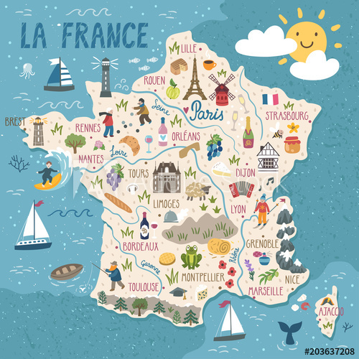

‼️ Including work to be completed by September ‼️

We hope you are well and keeping yourselves busy during lockdown.
We have created this booklet to help you prepare for September when you start your two-year French A-level course.
First of all, here is a link to the course specification: https://www.aqa.org.uk/subjects/languages/as-and-a-level/french-7652

Below are the content of exams (that you will take at the end of the course in 2022) and the course content (the topics you will study over the next two years).

Content of exams:
- Paper 1 - Listening, Reading and Writing + Translation (Fr to Eng and Eng to Fr)
  - based on all topics studied in Years 12 and 13
  - 2hrs 30 mins, 100 marks, worth 50% of A-Level
- Paper 2 - Essay paper – written in French
  - 2 x essays: 1 x book and 1 x film (approx. 300 words each)
  - 2 hours, 80 marks, 20% of A-Level
  - Film to be studied ‘La Haine’
  - Book to be studied ‘L’Etranger’, Albert Camus
free pdf ebook available here: https://www.anthropomada.com/bibliotheque/CAMUS-Letranger.pdf
- Paper 3 – Speaking
  - Detailed discussion of one topic card from all topics studied in Years 12 and 13
  - Presentation and discussion on Individual Research Project (IRP)
  - Max 16-18 mins, 60 marks, 30% of A-Level

Year 12 topic content – Starting September 2020:
- La famille en voie de changement – Changing trends regarding family
- La cyber-société – Cybersociety
- Le rôle du bénévolat – the role of volunteering
- Le patrimoine - Heritage
- La musique francophone contemporaine – Contemporary French music
- Le septième art - the Seventh Art (cinema)

Year 13 topic content – Starting September 2021:
• Les ados, le droit de vote et l'engagement politique – Young people, the right to vote and political interest
• Manifestations, grèves – à qui le pouvoir ? – Protests, strikes – who has the power ?
• La politique et l'immigration – Politics and Immigration
• Les aspects positifs d'une société diverse – Positive aspects of a diverse society
• Quelle vie pour les marginalisés ? – The life of marginalised people
• Comment on traite les criminels – How criminals are treated

Up to GCSE level, French is a skill-based subject. This means that rather than content, you have been learning how to understand written and spoken French, and how to communicate in written and spoken French.

At A-Level, you are using the skills you have acquired during GCSE to study the topics above and to widen your cultural awareness of the Francophone society.
Before September, we would like you to keep working on your French and to ensure you consolidate your knowledge of grammar.

In order to work on your READING skills, you can use the following resources:

1jour1actu provides brilliant resources for both reading and listening. Pick one of these suggested articles and read it through trying to understand the gist. You will not understand every single word and that is normal.
When there is one, you can complete the interactive quiz at the end to check your understanding.
Then try to write a short summary (50-70 words) of the article. Summarising is a new skill at A-Level so it would be useful to start getting your head around it.
Write the summaries in your simple GCSE vocabulary so it is written in your own words rather than copied from the articles.
Links to articles linked to Year 12 subject content:
Famille
Technologie
Bénévolat
Patrimoine
Musique
Cinéma
In order to work on your LISTENING skills, you can use the following resources:
# If you are subscribed to Netflix and/or Amazon Prime, here are links to lists of French-speaking films you will be able to watch on these platforms.
Type ‘French’ in the search bar and you will find a lot of different films and TV series.
You can then add English or French subtitles depending on how you want to challenge yourself.
Ultimate list of French films on Netflix: https://frenchflicks.com/read-49/items/watch-french-films-on-netflix-2019.html
Ultimate list of French films on Amazon Prime: https://frenchflicks.com/read/items/the-best-french-films-on-amazon-prime.html

# You can watch videos from 1jour1actu – simple vocabulary, all sorts of topics related to current events (you have seen similar clips in lessons)
You can also find the videos on YouTube and slow the speed down.
Bénévolat
Technologie
Politique
Cinéma

# Brut – more complex and some longer videos but usually with French subtitles to support you
Immigration
Diversité
Musique
Cinéma

# Discover French music on Spotify: https://open.spotify.com/search/musique%20francaise

# Find a French song/band/artist you like and complete the gap-fills until you can complete ‘advanced’ (or even ‘expert’?!) https://lyricstraining.com/fr/

# News and current affairs
- News in Slow French: https://open.spotify.com/show/3sbOvAVL6IIdMjop1r4i1G
- https://www.1jour1actu.com/ watch at least one episode of news every week, making a note of ANYTHING you understand and ignoring what you don’t for now.
- Start following at least 3 different French language news outlets on social media – aim to find some each from a range of French-speaking countries, or even a selection from each continent

Grammar - It is VERY important you are confident with GCSE grammar.
This includes the different tenses, as well as agreements (nouns, articles, and adjectives), using adverbs, pronouns, and some more complex structures.
To consolidate your Grammar knowledge, you can use:
# https://conjuguemos.com/ You will find instructions how to access it below.
Click on use without account

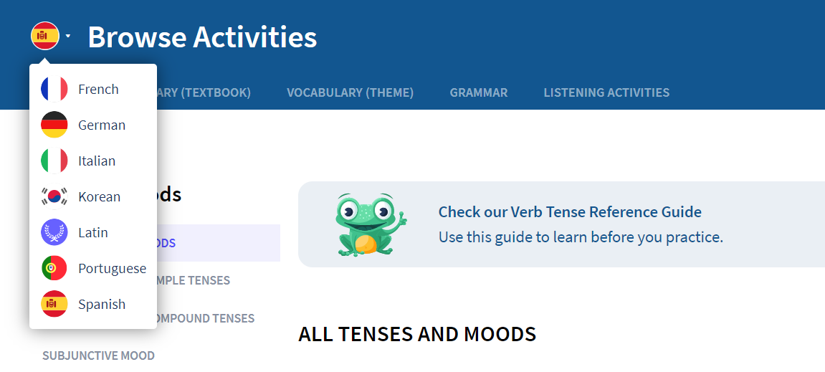
Select French
Support and tasks to consolidate your knowledge of grammar
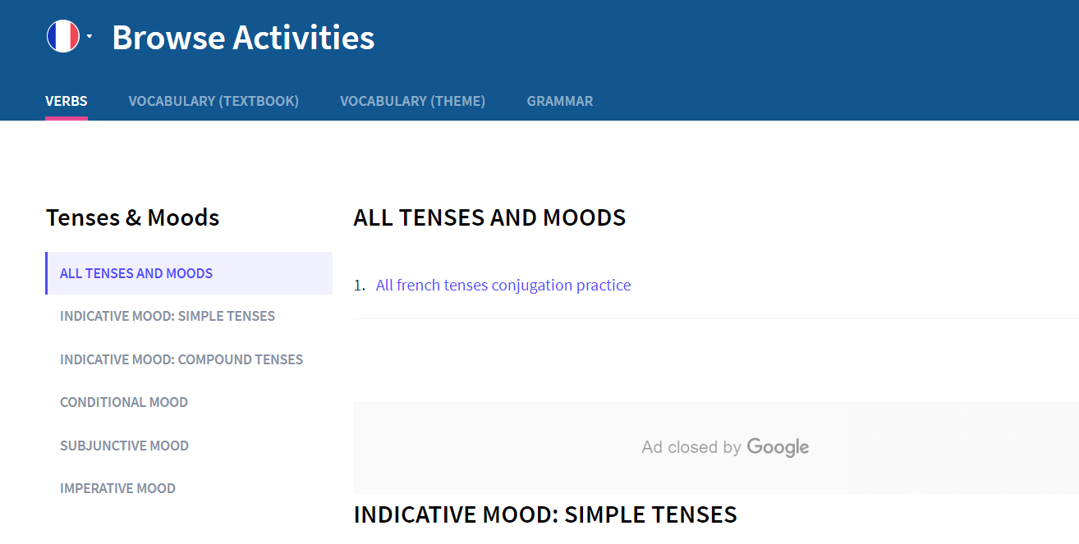
# Grammar sheets available on Kerboodle using your school login.
If for some reason you cannot access the grammar resources using the digital book, please email Miss Brousse.
# You can also use the following website: https://www.languagesonline.org.uk and use the Grammar section.
Finally, below are grammar tasks for you to complete for September.
If you would like support (or further work!), please email Miss Brousse.
Exercise 1 - adjectives
Complete the following sentences with the correct spelling of the adjective given in brackets:
1 Ils habitaient dans une (beau) maison (blanc).
2 Nos (nouveau) vélos ont marché super bien.
3 Son (ancien) équipe de foot ne gagne plus de matchs sans lui.
4 Quels sont les (meilleur) endroits à visiter?
5 Aujourd’hui nous avons vu un (vieux) homme aux cheveux
(long) et (gris).
Exercise 2 – comparatives & superlatives
Complete the following sentences to convey the information given in brackets:
1 Mon frère est son copain. (taller than)
2 Ces livres étaient ceux-là. (less interesting than)
3 Les filles seraient peut-être les garçons? (better than)
4 Est-ce que l’espagnol est le français? (as hard as)
5 La peur des araignées la peur des serpents. (worse than)
6 Ce lac est d‘Europe. (the deepest)

Exercise 3 – comparatives & superlatives continued
Make every element of the following sentences plural:
1 Il était plus doué que sa sœur.

2 La souris sera plus rapide que le chat.

3 Cette pomme est aussi sucrée que la poire.

4 Où serait le meilleur endroit pour moi?

Exercise 4 – possessive adjectives
Insert the correct possessive adjective into each of the following:
1 (His) parents lui disent qu’il devrait nettoyer (his) chambre.
2 (Their) voisins vont toujours en vacances en Italie ou en Espagne.
3 (My) copine m’aidait souvent, mais jamais (her) frère.
4 Un de (our) problèmes, c’était qu’on ne savait ni le nom de (their)
rue, ni le numéro de (their) maison.
5 Où as-tu trouvé (our) adresse email ?

Exercise 5 - prepositions
Translate the following sentences into English. Beware of the literal translation – it may not always be appropriate:
1 Chez les adolescents, on voit souvent des problèmes de respect de soi.

2 Le voleur a pris le passeport de la jeune fille dans la poche de son sac-à-dos.

3 Je crois qu’ils vont partir en taxi pour l’aéroport vers deux heures.

4 À mon avis, tu devrais faire des recherches avant de prendre ta décision.

5 En tant que membre du comité, il a le droit de donner son opinion.

Exercise 6 – present tense irregular verbs
Complete the following text in the present tense using the correct parts of the irregular verbs used:
Je (vivre) en Angleterre, mais j’ (avoir) une tante qui
(vivre) en France. Elle (dire) qu’elle (devenir) de plus en plus
française. Elle nous (voir) souvent parce qu’on (aller) en
France presque chaque année à Noël. Le seul problème pour ma tante,
c’ (être) qu’elle (souffrir) de la chaleur, alors elle
(revenir) en Angleterre au mois d’août.

Exercise 7 – reflexive verbs (mixed tenses)
Complete the following sentences with the correct tense of the verb given:
1 Quand elle elle tout de suite. (se réveiller,
se lever)
2 Je crois que nous allons très bien. (s’entendre)
3 Les enfants bien et puis ils commencent à
. (s’amuser, s’ennuyer)
4 Hier, mon père en . (se couper,
se raser)
5 Ce soir on tôt parce qu’il faudra
tôt demain pour prendre l’avion. (se coucher, se lever)
Exercise 8 – perfect tense
Insert the correct past participle to complete the following sentences, making it agree where necessary:
1 Nous avons (finir) très tard hier et puis nous sommes (partir).
2 Les filles ont (décider) d’aller en ville où elles ont (voir)
des copains.
3 Le professeur leur a (dire) d’écouter attentivement mais les élèves n’ont
pas (suivre) ses instructions.
4 Elle est (monter) dans sa chambre et puis elle s’est
(se coucher).
5 Quand j’ai (ouvrir) la porte, le chien est vite (sortir).

Exercise 9 – perfect tense continued
Translate the following sentences:
1 She lived there for three years. (use vivre)

2 They did not come back to make a cake.

3 He has written a fantastic book.

4 We washed in the village fountain.

5 You wanted to continue with the story.

Exercise 10 – future tense
Give the infinitive of the verbs being used in the future or immediate future tense in the following sentences:
1 Mon mari ne pourra pas venir avec nous en vacances cette année parce qu’il devra
aller à une conférence aux États Unis.
2 Ma fille n’aura pas le temps de finir ses études si elle veut suivre son copain et aller
en Australie cette année.
3 Je vais voir mon beau-père bientôt mais on ne fera pas grand’chose ensemble
parce qu’il sera très préoccupé avec les affaires de son entreprise.

4 Mon frère ne se mariera pas avec son partenaire parce que, pour l’instant, il préfère
simplement se pacser avec lui. Ils vont se marier plus tard.

5 Quand on ira en Espagne, l’année prochaine, il y aura peut-être des problèmes à la
frontière, parce que mon demi-frère n’a pas de passeport.

Exercise 11 – conditional tense
Underline the verbs and say whether they are in the present, future, imperfect or conditional tenses, then translate the sentences:
1 Quand ma mère va au supermarché, elle oublie toujours sa liste.

2 Quand on verra ta sœur, on fera la connaissance de son petit ami.

3 Il y aura beaucoup de monde à la fête du village s’il ne pleut pas.

4 Si on voulait visiter le chateau, on pourrait y aller cet après-midi.

5 Qu’est-ce que tu ferais si tu gagnais à la loterie?

Exercise 12 – conditional tense continued
Translate the following sentences into French:
1 I will go to the States when I have enough money.

2 When he sees the gift he will be so happy.

3 If we looked on the Internet, we would discover lots of information.

4 His parents always tell him to be careful when he uses his mobile phone.

5 She would do better, if she followed your advice.

6 What could we do, especially when there were so many people?

Exercise 13 - negatives
Rewrite the following sentences in the negative, replacing any underlined phrases and making any adjustments necessary:
1 Elle fait beaucoup de choses aujourd’hui. (ne…rien)

2 Le Monsieur désire prendre cette chambre. (ne…point)

3 On a toujours voulu visiter la Russie. (ne…jamais)

4 Ils mangent des fruits et des légumes. (ne….que)

5 Ils boivent du vin et de la bière. (ne…ni…ni)

Exercise 14 – negatives continued
Make the following sentences negative, using the words given in brackets and making any necessary adjustments:
1 Je lui ai parlé. (ne ….jamais)

2 La fille va me l’envoyer plus tard. (ne…pas)

3 (Ces enfants) On les verra. (ne….plus…jamais)

4 (La vérité) Tu la lui as dit hier soir. (ne…pas)

5 (Les règles) Nous devrons les leur expliquer. (ne….rien)

Research work to be completed for September

Les personnes importantes

Pourquoi ces personnes sont-elles connues ? What are these people famous for ?

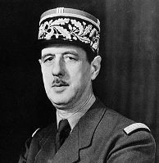
Charles de Gaulle
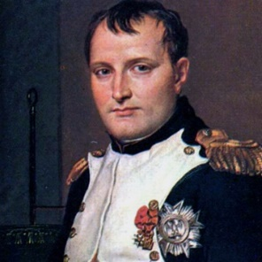
Napoléon Bonaparte
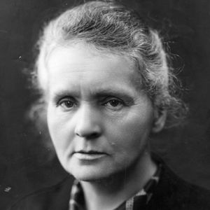
Marie Curie
Coco Chanel
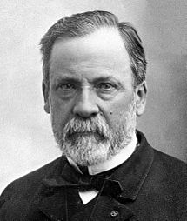
Louis Pasteur
Jeanne d’Arc
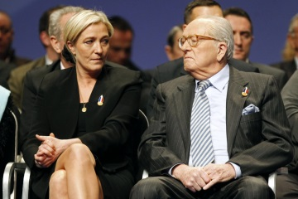

Jean Marie et Marine Le Pen
Albert Camus
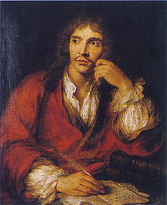
Molière
La politique française

- Qui est le président de la France ?
_________________________________________________

- Il a été élu quand ?
_________________________________________________

- Il représente quel parti politique ?
_________________________________________________

Research the different political parties, their ideas, leaders etc.

En Marche !
Les Républicains
Le Parti Socialiste
Le Front National

Fact sheet about France:
Make a list of interesting facts (in English or in French) about France or any French-speaking country, ready to share with the class in September.
This could include popular food and drinks, celebrities, Geography, History, Music or Cinema.
1
2
3
4
5
6
7
8
Suggested Purchases:

AQA A-level French Revision and Practice Workbook: Themes 1 and 2 (Revision & Practice Workbook 1)
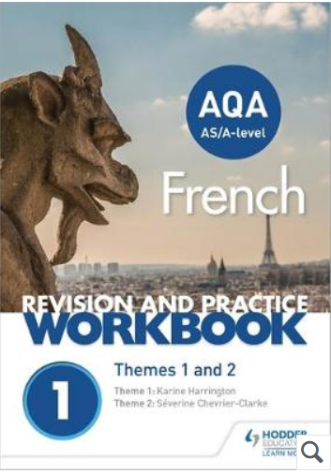
Available on Amazon for £8.99 https://www.amazon.co.uk/level-French-Revision-Practice-Workbook/dp/1510417737

AQA A Level French: Grammar & Translation Workbook Paperback
Available on Amazon for £7.99
https://www.amazon.co.uk/AQA-Level-French-Translation-Workbook/dp/0198415532/ref=sr_1_1?ie=UTF8&qid=1527182094&sr=8-1&keywords=french+grammar+a-level
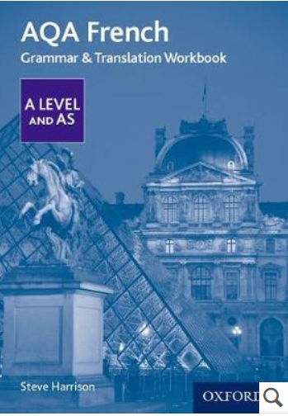

Summer FRENCH to do list

- I have read the course specification
- I have completed all the grammar tasks
- I have completed all the research work
- I have consolidated my understanding of present tense
- I have consolidated my understanding of near future
- I have consolidated my understanding of past tense
- I have consolidated my understanding of conditional
- I have listened to French music every week
- I have listened to the news in Slow French on Spotify
- I have watched at least two films in French
- I have read in French every week
- I have completed my fact sheet
