

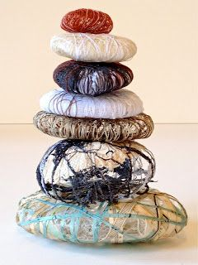

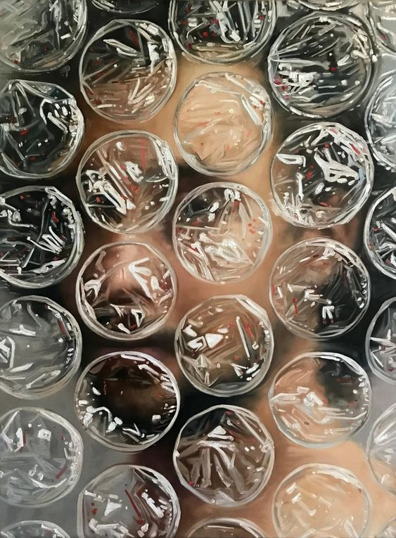

CONCEAL

Disguise, obscure, cover-up, wrap, shelter, camouflage, veil, hide, privacy, cover……..

Respond to the theme in a range of visual ways. Try to explore one aspect of the theme rather than lots of different ideas

This means studies in a range of media such as pencil, charcoal, paint, pastel, 3D materials, textiles, collage, printmaking, photography etc. working on a range of different surfaces and at different scales.

You should make reference to the work of an artist and include examples of their work. Make hand copies of their work in appropriate media and some annotation (in your own words) as to why you chose that artist. The artist may have been chosen for a variety of reasons so make it clear.

REMEMBER we are looking for a personal approach and are keen to see what you can achieve independently in preparation for the demands of A Level. This is not a whole project so do not spend the whole of the summer working.

You should aim to complete *the equivalent* of 4 x A2 sheets. The work can be presented on A2 card or left loose and unpresented.

Enjoy!! See you in September (fingers crossed!)