Aspirational Readers
Whether you are studying for GCSEs or A-Levels, reading a wide range of challenging texts will broaden your horizons and help you succeed in English. We love reading and, as a department, we want to share our ‘Top Ten’ favourite books with you.

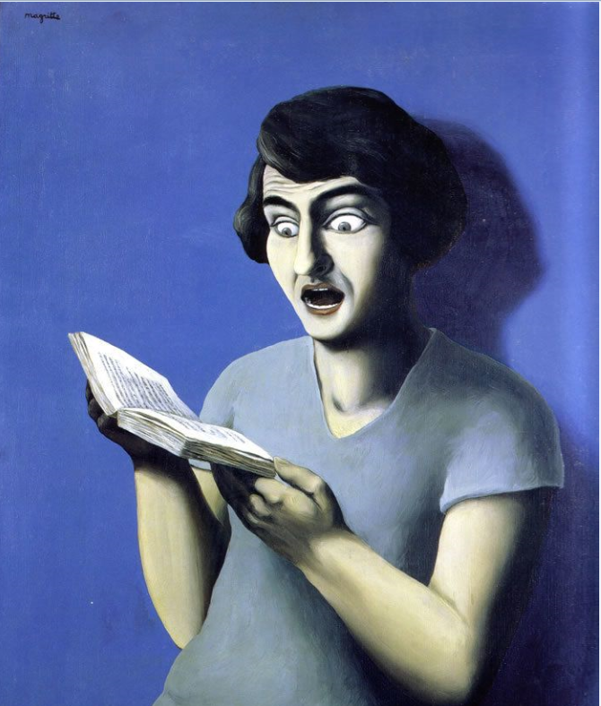
Mr Fox Goddard
Title | Author | Genre | Synopsis
Time’s Arrow | Martin Davis | Drama | Narrative in reverse. A war criminal is forced to confront his crimes against humanity.
Seeds of Greatness | Jon Canter | Comedy | The story of someone whose best friend becomes incredibly famous
Cloud Atlas | David Mitchell | Short Stories | A series of interconnected half-stories ranging from the 1800s to the distant future.
Pavel and I | Vyleta | Crime | Crime drama set in the freezing winter of 1946 in Berlin
Captain Correlli’s Mandolin | Louis de Bernieres. | Romance | Romance on set on a Nazi-occupied Greek island in WW2
The Picture of Dorian Grey | Oscar Wilde | Gothic | Arrogance and narcissism in Victorian England.
The Life of Pi | Yann Martel | Fantasy | A boy is cast adrift in the oceans with a collection of zoo animals.
The First Fifteen Lives of Harry August | Claire North | Science Fiction | A new twist on the time travel genre
The Wasp Factory | Iain Banks | Horror | Nasty and compelling debut novel
The Name of the Rose | Umberto Eco | Crime | Medieval Crime Caper set in a monastery
Frankenstein | Mary Shelley | Gothic | A tour de force of the imagination and arguably the first real science fiction novel.

Mr Guest
Title | Author | Genre | Synopsis
The Handmaid’s Tale | Margaret Atwood | Dystopian | Set in the near future, a totalitarian religious state has emerged to take control in America.
The Things They Carried | Tim O’Brien | War | Collection of related stories about a platoon of American soldiers fighting in the Vietnam War.
Short Stories of Sherlock Holmes | Sir Arthur Conan Doyle | Detective | Sherlock Holmes solves a range of bizarre mysteries through the power of deduction.
Do Androids Dream of Electric Sheep? | Philip K Dick | Sci-Fi | Made in to the film ‘Blade Runner’ this novel presents an Earth damaged by nuclear war. Through its ruins, a bounty hunter for renegade androids to ‘retire’.
The Crow Road | Iain Banks | Murder/  Mystery | A powerful and menacing Scottish novel through which Prentice McHoan's troubled life is described.
Return of the Native | Thomas Hardy | Tragedy | Set in Hardy’s Wessex, amidst the menacing beauty of Egdon Heath, numerous characters are driven to self-destruction.
The Catcher in the Rye | J.D. Salinger | Teenage | Teenage rebellion in 1950s America. Deals with the themes of identity, loss and alienation.
Enduring Love | Ian McEwan | Thriller | A couple are celebrating with a picnic when a cry interrupts them. A hot-air balloon, with a 10-year-old boy in the basket and his grandfather being dragged behind it, has been ripped from its moorings…
One Flew Over the Cuckoo’s Nest | Ken Kesey | Humour | One man’s fight against an oppressive regime, set in an American mental institution.
1984 | George Orwell | Dystopian | Set in a nightmare future, Winston Smith challenges the power of ‘Big Brother’.

Mrs Mullowney
Title | Author | Genre | Synopsis
Jane Eyre | Charlotte Bronte | Gothic | A classic novel that follows the eponymous Jane Eyre as she falls in love with Rochester, who hides a secret.
The Handmaid’s Tale | Margaret Atwood | Dystopian | Set in the near future, a totalitarian religious state has emerged to take control in America.
The Testaments | Margaret Atwood | Dystopian | The Long-awaited sequel to The Handmaid’s Tale.
Brooklyn | Colm Toibin | Fiction | A devastating story of love and loss as a young woman immigrates to America and then finds herself facing a difficult choice.
We Need to Talk About Kevin | Lionel Shriver | Fiction | A frightening and compelling story of a mother as she comes to terms with the terrible senseless murders her son committed.
Normal People | Sally Rooney | Fiction | An on/off coming of age love story.
The Book Thief | Markus Zusak | Historical Fiction | Narrated by ‘Death’ this book follows a nine year old girl as she experiences the horror of the Nazi regime.
A Thousand Splendid Suns | Khaled Hosseini | Fiction | A powerful story that explores the experiences of two girls in war ravaged Afghanistan.
The Hand That First Held Mine | Maggie O’Farrell | Fiction | Using two timelines, this novel explores ideas of motherhood.
Brother of the More Famous Jack | Barbara Trapido | Fiction | A highly acclaimed book that is said to redefine the ‘coming-of-age’ genre

Title | Author | Genre | Synopsis
The Book Thief | Markus Zusak | Historical Fiction | Narrated by ‘death’ the story follows a young evacuee in Nazi Germany and a tale of the people she meets!
Bridge of Clay | Markus Zusak (sorry, but he’s an excellent writer and I’ve met him! A lovely person) | Fiction | An emotional story about five brothers living on the poverty line in Australia, featuring some very interesting animals!
Eleanor Oliphant Is Completely Fine | Gail Honeyman | Fiction | A story following a unique young woman named Eleanor. Very funny and sad both in equal measure. A must read.
The Immortalists | Chloe Benjamin | Fiction | Story following four siblings who find out when they are going to die… A very interesting novel.
Animal Farm | George Orwell | Dystopian Fiction/ Classic Fiction | A group of farm animals overthrow the farmers and run their own farm. Are all animals created equal? Or are some more equal than others?
I Am Malala | Malala Yousafzai | Non Fiction | The excellent autobiography written about the extraordinary life of Malala, the young girl who was shot for standing up to education.
Colorless Tsukuru Tazaki and His Years of Pilgrimage | Haruki Murakami | Fiction | From an excellent Japanese author comes the story of a very tight knit group of friends and sudden distancing. What did he do to make them all ignore him?
The Curious Incident of the Dog in the Night-time | Mark Haddon | Fiction | A book featuring a very interesting outlook on life from young Christopher. A story about a dog, car colours and facing your fears.
The Lonely Londoners | Sam Selvon | Fiction | A book documenting the migration of immigrants into London. A book written in accents! Very interesting.
Trainspotting | Irvine Welsh | Fiction | This book made me gasp out loud in a train carriage full of people, full of insane stories and some very strong Scottish accents!
Miss Harris

Mr Collyer
Title | Author | Genre | Synopsis
The Lord of the Rings (1954-1955) | J.R.R Tolkien | Fantasy | A group of nine humans, elves, dwarves and hobbits set out on a quest to destroy a magic ring.
The Hobbit (1937) | J.R.R Tolkien | Fantasy | A reluctant hobbit is forced to go on a quest to take back a group of dwarves’ mountain home.
The City and the City (2009) | China Miéville | New Weird | The body of a murdered woman is discovered in the crumbling European city of Besźel. To solve the crime, Inspector Tyador Borlú must travel to a city that is a rival of his own.
Death and the Penguin (1996) | Andrey Kurkov | Satire / surrealism | Follows the life of a young writer, Viktor, and his pet penguin, Misha in post-Soviet Ukraine. Viktor is asked to write obituaries for people who have not died yet. He becomes suspicious when the list of people he has written obituaries for, begin to die.
The Godfather (1969) | Mario Puzo | Crime | Follows the Corleone crime family after their head, Vito Corleone, is shot by men working for a drug dealer.
The Curious Incident of the Dog in the Night-Time (2003) | Mark Haddon | Mystery | Charts the attempts of Christopher Boone, a boy with severe Asperger syndrome, to find out who killed his neighbour’s dog, Wellington.
Watchmen (1986-1987) | Alan Moore and Dave Gibbons | Graphic novel/comic book. | In an alternate 1985 America, costumed superheroes are part of everyday life. When one of his former comrades is murdered, masked vigilante Rorschach uncovers a plot to kill and discredit all past and present superheroes.
Carrie (1974) | Stephen King | Horror | A girl being bullied develops telekinetic powers and extracts revenge on those bulling her.
Please Don’t Come Back From the Moon (2005) | Dean Bakopoulos | Magic Realism | In a rust-belt community affected by deindustrialisation and unemployment, fathers begin abandoning their families.
A Game of Thrones (1996) | George R. R. Martin | Fantasy | Follows the Stark family in their dealings with conspiracy and court politics in the Seven Kingdoms of Westeros.

Mrs Bridges

Title | Author | Genre | Synopsis
The Woman in Black | Susan Hill | Gothic/Horror | Arthur Kipps relates his haunting experiences at Eel Marsh House. The tale begins on Christmas Eve, when Arthur's step-children invite him to tell a ghost story. Arthur is too disturbed by his memories to share his story aloud, so he writes it down.
Little Women | Louisa May Alcott | Romance | The story revolves around the lives of four sisters growing up during and after the Civil War. With their father off fighting the war, the girls face the hardships and constraints of poverty and social expectations.
The Lovely Bones | Alice Sebold | Fiction | The story of a teenage girl who, after being murdered, watches from her personal heaven as her family and friends struggle to move on with their lives while she comes to terms with her own death.
12 Years a Slave | Solomon Northup | Autobiography/ Memoir | Solomon Northup recounts his life as free black man from the North who was kidnapped and sold into Slavery in the Pre- Civil War South.
My Sister’s Keeper | Jodi Picoult | Fiction | It tells the story of 13 year old Anna Fitzgerald, who sues her parents for medical emancipation when she discovers she was supposed to donate a kidney to her elder sister Kate, who is gradually dying from acute leukaemia.
Gone Girl | Gillian Flynn | Thriller | Nick and Amy present a portrait of a perfect marriage to the public. However, when Amy disappears on the couple’s fifth wedding anniversary, Nick becomes a prime suspect in her disappearance.
The Tattooist of Auschwitz | Heather Morris | Historical Fiction | In April 1942, Lale Sokolov, a Slovakian Jew, is forcibly transported to the concentration camps at Auschwitz-Birkenau. When his captors discover that he speaks several languages, he is put to work as a tattooist, tasked with permanently marking his fellow prisoners.
Eleanor Oliphant is Completely Fine | Gail Honeyman | Romance/ Psychological Fiction | This is the story of an out-of-the-ordinary heroine whose deadpan weirdness and unconscious wit make for an irresistible journey as she realizes the only way to survive is to open your heart.
The Girl on The Train | Paula Hawkins | Mystery/ Thriller | Rachel catches the same train every morning. She knows it will wait at the same signal each time, overlooking a row of back gardens and houses. One day she sees something shocking, and in one moment everything changes.
Noughts and Crosses | Malorie Blackman | Dystopian Fiction | A dystopian Romeo and Juliet that makes eloquent statements about race relations and the burning passions of the teenage heart.

Miss Reeve
Title | Author | Genre | Synopsis
The Penguin Lessons | Tom Michell | Faction | The true story of Juan Salvador the penguin, rescued by a young British man (Tom) from an oil slick in Uruguay just days before the start of a new term at the boarding school where Tom lives and works.
Where the Crawdads Sing | Delia Owens | Fiction | The life and loves of an isolated girl who grows up in the wild swamps of North Carolina.
White Chrysathemum | Mary Lynn Bracht | Fiction | The story of two Korean sisters separated by the Second World War.
On Canaan’s Side | Sebastian Barry | Fiction | Lilly’s life story, from being forced to flee Dublin at the end of the First World War to settling in America.
A Little Life | Hanya Yanagihara | Fiction | Four university friends move to New York to start adult life. It’s about friendship, suffering and survival.
Remarkable Creatures | Tracy Chevalier | Historial fiction | Two eccentric women search for fossils on English beaches.
The Sealwoman’s Gift | Sally Magnusson | Fiction | Icelandic history is brought to life. In 1627 Barbary pirates raided the coast of Iceland and abducted 400 people, taking them across the sea to be sold into slavery in Algiers.
Transcription | Kate Atkinson | Fiction/historical | Juliet is recruited as a young woman by an obscure wartime department of the secret service. In the aftermath of war she joins the BBC, where her life begins to unravel, and she finally has to come to terms with the consequences of idealism.
American Psycho | Bret Easton Ellis | Fiction | With lots of violence, mostly against women, this story provides an exposure of modern life’s materialistic and superficial excesses.
The Children Act | Ian McEwan | Fiction/suspense | For religious reasons, a 17 boy, Adam, is refusing the medical treatment that could save his life, and his devout parents share his wishes. Time is running out. The court could overrule him because he’s under 18 – but what will the judge decide?

Mr Milligan
Title | Author | Genre | Synopsis
The Remains Of The Day | Kashuo Ishiguro | Tragedy | Booker Prize winning book about an ageing butler (just try it!)
The Great Gatsby | F Scott Fitzgerald | Tragedy | Gatsby’s raised enormous wealth to get a girl, but his past may stand in their way.
The God of Small Things | Arundati Roy | Fiction drama | The story of Rahel’s childhood that drastically changed the lives of everyone in the family.
The Kite Runner | Khaled Hosseini | Redemption | The story of Amir, who tries to rebuild his life until an old friend offers him a way to make amends for his guilty past.
A Tale of Two Cities | Charles Dickens | Historical fiction | The best of times, and the worst of times in London and Paris during the French Revolution.
Regeneration | Pat Barker | Biography, war | The novel explores the PTSD of British officers at Craiglockhart War Hospital, including Wilfred Owen, during WW1
Fire From Heaven | Mary Renault | Biography | The first book in the trilogy about Alexander the Great
The Color Purple | Alice Walker | Epistolary confession | The heart rending traumas and triumph of Celie, a young African American woman
Shantaram | Gregory David Roberts | Autobiography | A convicted Australian bank robber and heroin addict escapes from Prison and flees to India.
Heart Of Darkness | Joseph Conrad | Novella, historical fiction | Marlow’s journey up the Congo river to meet the enigmatic Kurtz

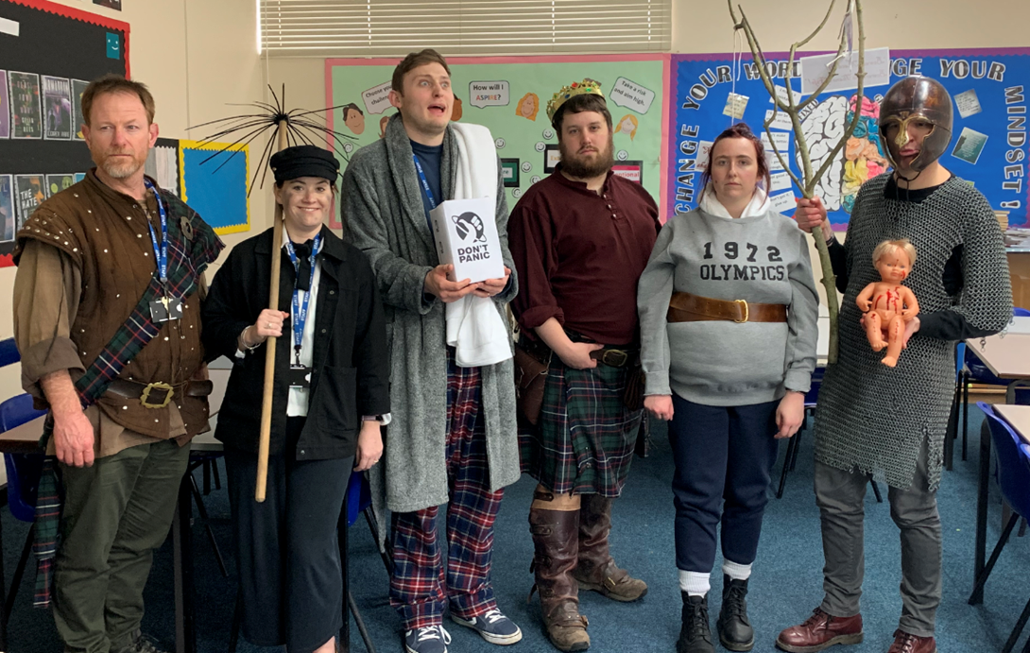

“So please, oh PLEASE, we beg, we pray, go throw your TV set away, and in its place you can install, a lovely bookshelf on the wall.”

- Roald Dahl, Charlie and the Chocolate Factory

